**Yotpo Hybris Extension**



***YotpoExtension Version _._._***



Table of Contents

1. Summary 3

2. Component Overview 4

2.1 Functional Overview 4

2.2 Use Cases 4

2.2.1 Use Case #1: Product Review Widget 4

2.2.2 Use Case #2: Star Rating Widget 4

2.2.3 Use Case #3: MAP [Order Export] 4

2.3 Limitations, Constraints 4

2.4 Compatibility 5

2.5 Privacy, Payment 5

3. Implementation Guide 6

Prerequisites 6

3.1 Setup 6

3.2 Configuration 6

3.2.1 Extension Registration 6

3.2.2 Build & System Update 6

3.2.3 Import Yotpo Configurations and Jobs Data 7

3.2.4 Set up the yotpoConfiguration 7

3.2.5 Set up the yotpoJobsConfiguration 9

3.2.6 Time Schedule Yotpo - Export Orders Job 9

3.2.7 Create a new Yotpo - Export Orders Job instance 10

3.2.8 Create a new Yotpo - Configurations instance 11

3.3 Custom Code 12

3.1.1 Adding Extension Dependency 12

3.1.2 Adding Yotpo Modules. 12

3.1.3 Adding Yotpo JavaScript to your store. 13

3.1.4 Adding Product Review Widget 13

3.1.5 Adding Star Rating Widget 13

3.1.6 Adding Purchase Conversion Tracking 14

4. Operations, Maintenance 15

4.1 Availability 15

4.2 Support 15

5. User Guide 16

5.1 Roles, Responsibilities 16

5.2 Platform Configuration Properties 16

5.3 Storefront Functionality 17

6. Known Issues 18

7. Release History 19

# Summary

SAP Hybris ecommerce platform is based on Spring framework and highly customisable. Yotpo is a SAP Hybris plugin utilises SAP Hybris extensible feature and adds reviews and marketing features to SAP Hybris commerce application.Yotpo manages customer reviews and drives traffic and sales through different channels

This document provides technical instructions for integratingYotpoHybris extension with SAP Hybris ecommerce application.

Clients using the Yotpoextension can access the following features:

1. Product Review Widget
2. Star Rating Widget
3. Mail After Purchase (MAP)

In order to use the Yotpoextension, customers must be in contract with Yotpo.

# Component Overview

## Functional Overview

Following is the list of features implemented in the Yotpoextension:

* Product Widgets
  + Product Review Widget.
  + Star Rating Widget.
* Mail After Purchase
  + Order export
* Analytics.
  + Purchase conversion tracking.
* For the storefront functionality to work properly, the following integration needs to be set up in Hybris Management Console
  + Purchasers Feed Export Generation.

## Use Cases

### Use Case #1: Product Review Widget



|  |  |
| --- | --- |
| Use Case Scenarios | Result |
| The merchant implements Product Review Widget in a page or pages in the store. | The user will be able to see Product Review Widgeton those store pages. |

### Use Case #2: Star Rating Widget

|  |  |
| --- | --- |
| Use Case Scenarios | Result |
| The merchant implements Star Rating Widget in a page or pages in the store. | The user will be able to see a Star Rating Widgeton those store pages. |

### Use Case #3: MAP [Order Export]

|  |  |
| --- | --- |
| Use Case Scenarios | Result |
| The merchant schedules the job that sends the order data to the YotpoAPI. | The user’s customers will receive MAPs according to the Yotpoaccount configuration. |

## Limitations, Constraints

Use of the YotpoExtension by itself does not grant nor enable use of Yotpo product offerings. Yotpo must separately come to a contractual agreement with the client in order for Yotpo to start collecting reviews on their behalf. Please contact Yotpo for details:<sales@yotpo.com>.

## Compatibility

The YotpoExtension is compatible with Hybris version 5.0 onwards.

## Privacy, Payment

Masked Order Information and Aggregate Sales Information may be captured as part of purchase tracking implementation on the site.

No customer specific profile data or sensitive information will be stored related to Yotpoextension.

The Extension cartridge itself is available free of charge. See "Limitations, Constraints" section for details regarding potential costs involved with enabling Yotpo to start collecting reviews on your behalf.

In using the Yotpoextension, you agree to be bound by our [Terms of Service](https://www.yotpo.com/terms-of-service/).

# Implementation Guide

## Prerequisites

A Yotpo representative must enable an account for the merchant, as part of which the merchant will be assigned a unique “app key” and “client secret key”.

## 3.1 Setup

The Yotpoextension uses the following extensions: yotpo, yotpoaddon. Once you are abided by Terms and Conditions place yotpo and yotpoaddon along with your other modules in custom directory or with relevant source directory.

## Configuration

### ExtensionRegistration

Navigate to the following path "[YUOR_DIRECTORY]>hybris>config"

Append the yotpo and yotpoaddon extension to config/localextensions.xml as shown below:

<extensions>

...

<extensionname="yotpo"/>

<extensionname="yotpoaddon"/>

</extensions>

### Build & System Update

Run your ant build and start your SAP Hybris server. Go to admin console and update your running system selecting yotpo, so it will update initial setup.

### Import YotpoConfigurations and Jobs Data

* Navigate to "hac>console>impex>ImpEx Import" and select "import script".
* Get the impex scripts files [essentialdataJobs.impex, projectdataYotpo.impex] from [YOUR_DIRECTORY]\hybris\bin\custom\yotpo\resources\impex and update the keys specific to your account and upload it through the upload page in Import Script.
* Click on "Import file"and complete the import process through the interface.

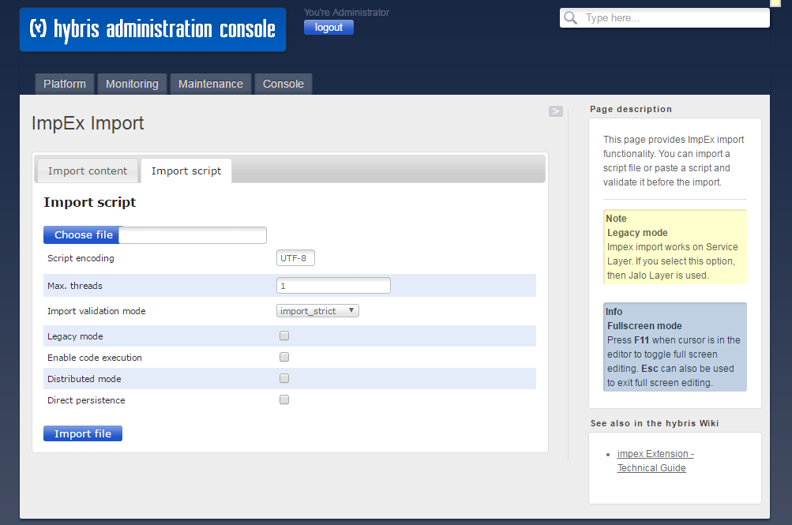

### Set up the yotpoConfiguration

Navigate to "hmc>hybris>Yotpo", Select "YotpoConfig" as shown below:

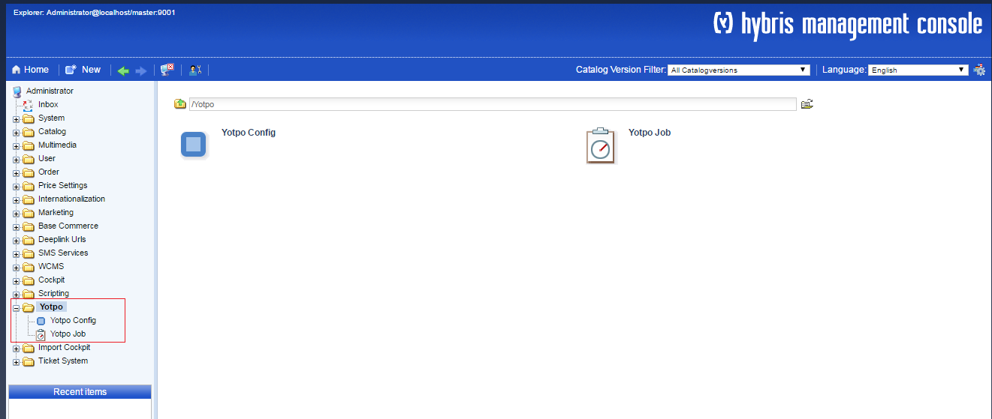

Search YotpoConfig as shown below:

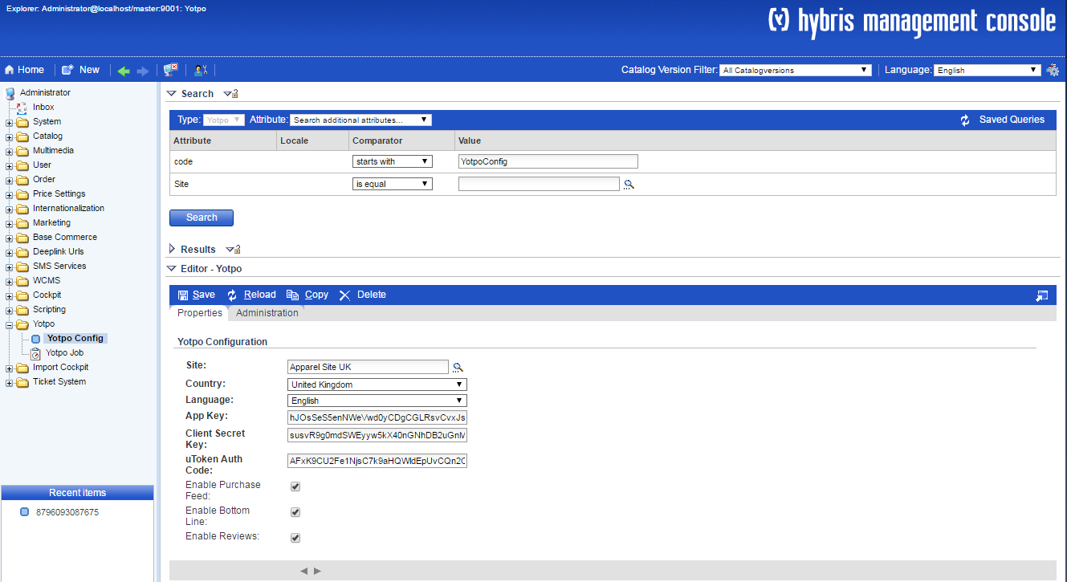

|  |  |
| --- | --- |
| **Custom Attribute Name** | **Function** |
| Site | The Site which represents a specific account on Yotpo. |
| App Key | An App key which can be used for a specific account on Yotpo |
| Client Secret Key | A Client Secret Key which contains information for a specific account on Yotpo |
| EnableBottomLine | A flag used to indicatewhether the star ratings are enabled or disabled for the specific site. |
| Enable Purchase Feed | A flag used to indicate whether the purchase feed is enabled or disabled for the specific site. |
| Enable Reviews | A flag used to enable or disable the reviews for the specific site. |
| utokenAuth Code | A token which retrieved from Yotpo Authentication call response. It remains valid for some hours before it expires. If once expires it is updated by the Yotpo authentication process automatically. |
| Country | Country for site, which represents a specific account on Yotpo |
| Language | Language for site, which represents a specific account on Yotpo |

## 

### Set up the yotpoJobsConfiguration

Navigate to "hmc>hybris>Yotpo", Select "Yotpo Job" as shown below:



Search YotpoOrderExportJobas shown below:

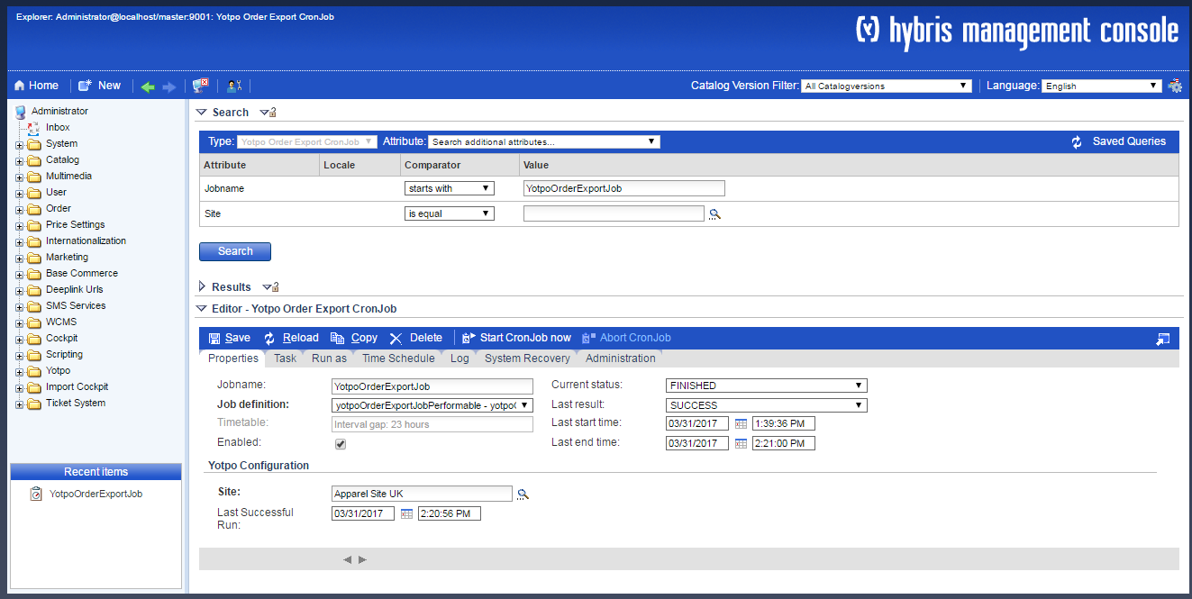

|  |  |
| --- | --- |
| Custom Attribute Name | Function |
| Last Successful Run | This attribute used to store the order feed job last successful execution date time. This is automatically updated by Export Orders process, however initially it should be set to some specific date in the past. |
| Site | The Site which represents a specific account on Yotpo. |

### Time ScheduleYotpo - Export Orders Job

Navigate to "hmc>hybris>Yotpo" and select "Yotpo Job", now search YotpoOrderExportJoband

select "Time Schedule" and click on "Trigger" as shown below:

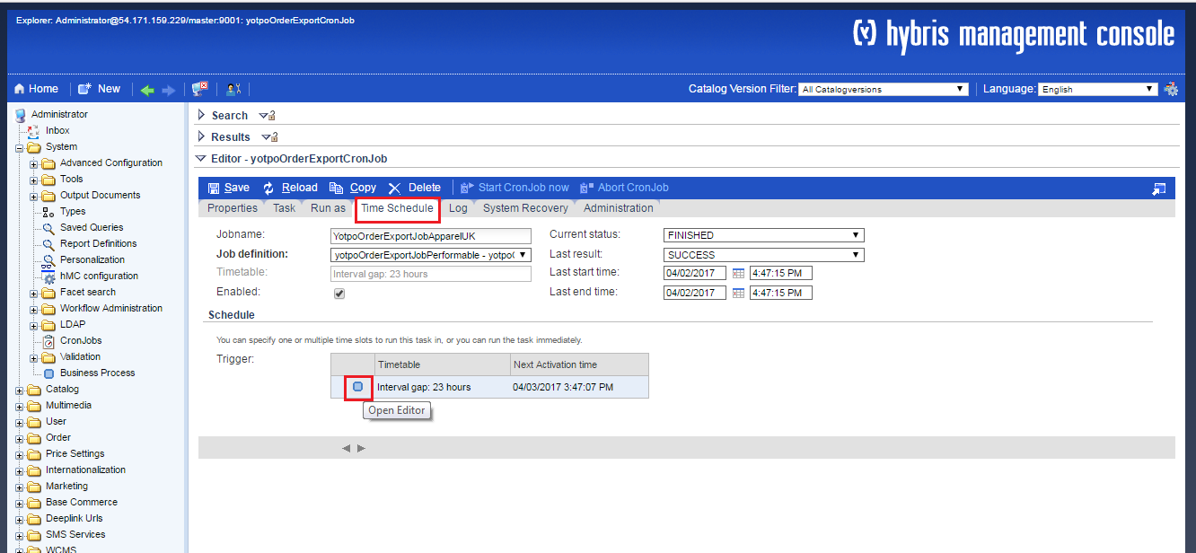

A pop up will appear as shown below:

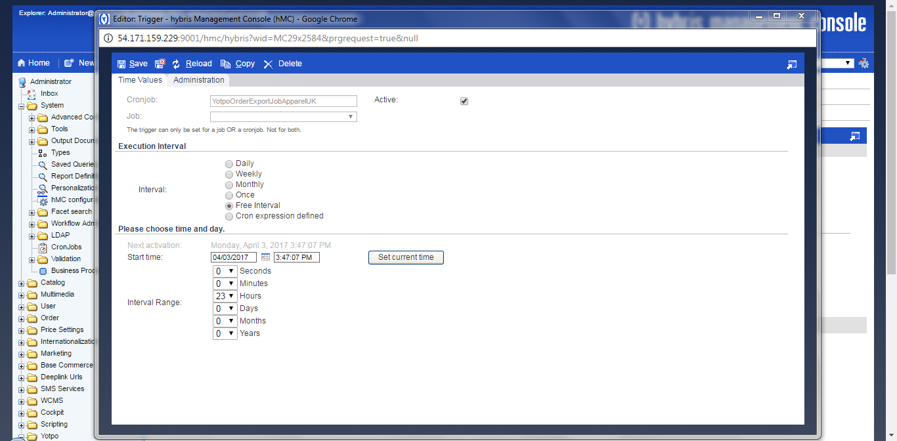

Change the time schedule as per requirement.

### Create a newYotpo - Export Orders Job instance

Navigate to "hmc>hybris>Yotpo" and select "Yotpo Job", now search YotpoOrderExportJoband select "Administration" and click on "Create Copy" as shown below:  
  
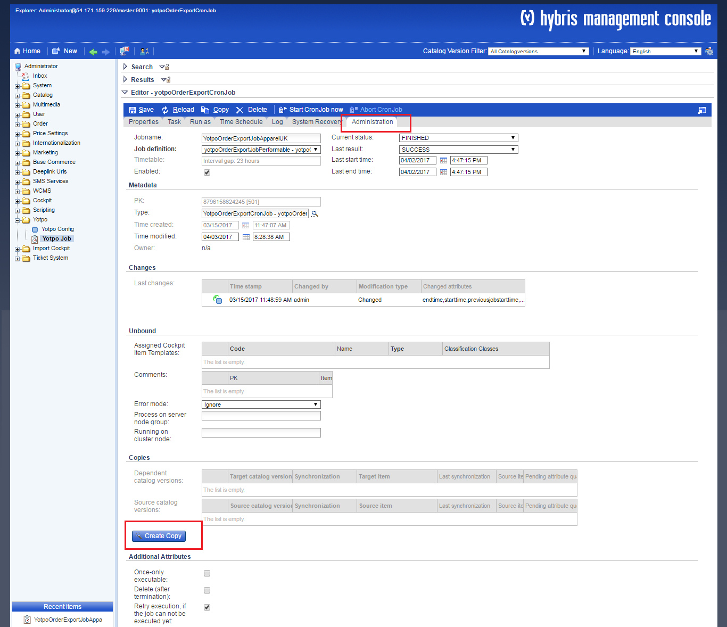

After this search the YotpoOrderExportJob and a copy of item will be visible in search results, edit this as per requirement.

### Create a newYotpo - Configurations instance

Navigate to "hmc>hybris>Yotpo" and select "YotpoConfig", now search YotpoConfig and select "Administration" and click on "Create Copy" as shown below:

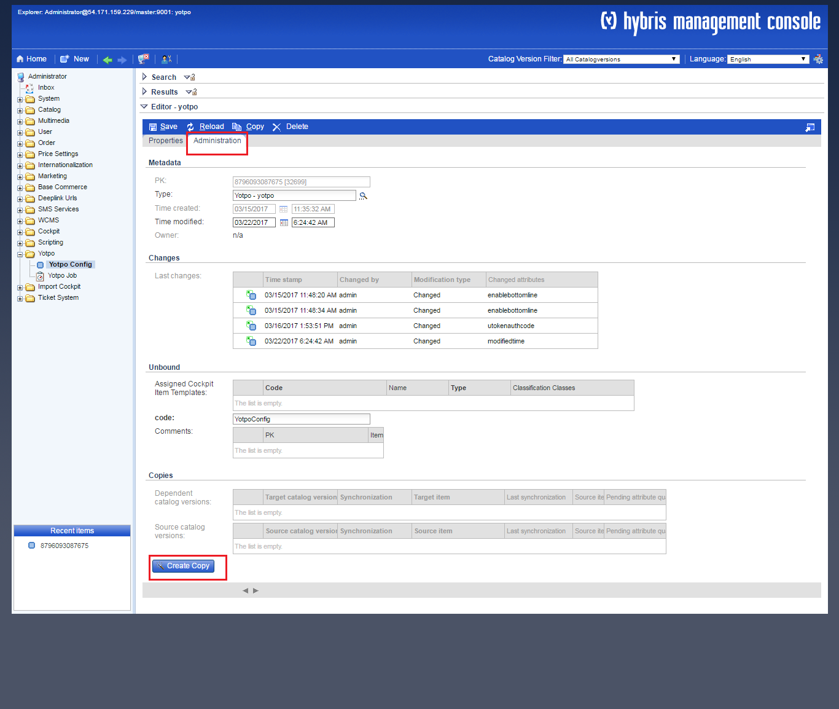

After this search the YotpoConfig and a copy of item will be visible in search results, edit item as per requirement.

## Custom Code

### Adding Extension Dependency

Add the following extension dependency in [YOUR_STOREFRONT_EXTENSION] > extensioninfo.xml as below:

<extensioninfo>

<extension>

...

<requires-extensionname="yotpo"/>

<requires-extensionname="yotpoaddon"/>

...

</extension>

</extensioninfo>

### Adding Yotpo Modules.

In order to add header,widgets and tracking modules make sure the file where you are adding it includes Yotpo modules definitions on top of each file:

<%@ taglib prefix="yotpo" tagdir="/WEB-INF/tags/addons/yotpoaddon/shared/analytics/yotpo" %>

### Adding Yotpo JavaScript to your store.

For widgets and conversion tracking to work, you must include Yotpo'sjavascript in your store by adding the following in your storefront header file i.e. header.tag:

<yotpo:yotpoheader />

### Adding Product Review Widget

Product Review Widget can be added to any product page in your store.

To add Product Review Widgetinclude following Yotpo widget tag definition code snippet to the desired page e.g. at the end of product details block in productDetailsPanel.tag

<yotpo:yotporeviewsproductData="${product}"/>



### Adding Star Rating Widget

Star Rating Widget can be added to any product page or in product tile in your store.

To add Star RatingWidgetinclude following Yotpo widget definition code snippet to the desired page e.g. after product ID in productDetailsPanel.tag

<yotpo:yotpobottomlineproductData="${product}"/>

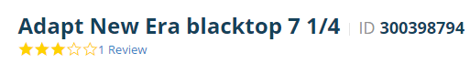

or add in productListerGridItem.tag after product price



### Adding Purchase Conversion Tracking

Conversion Trackingshould be added in “confirmation page” in your store.

In order to enable Conversion Trackinginclude following code snippet to the confirmation page i.e. at the end ofcheckoutConfirmationThankMessage.tag

<yotpo:yotpoconversiontrackingorderData="${orderData}" />

# Operations, Maintenance

## Availability

Yotpo services are based on a high-availability infrastructure and have 99.9% uptime. If Yotpo endpoints go down and your pages are unable to get reviews and from our servers, the Yotporeviewsand Star Rating will simply not show, it won’t degrade or break your page in any way.

## Support

Contact [Yotpo Support](https://my.yotpo.com/contact_support)regardingthis extension.

# User Guide

## Roles, Responsibilities

Yotpo Export Ordersjob should be scheduled to run daily.

Make sure **enablePurchaseFeed, enableReviews**and**enableBottomLine**is enabled in “hybris>hmc>Yotpo>YotpoConfig for a specific site.

## Platform Configuration Properties

The YotpoExtension consists of the following configuration properties in “hac>platform> configuration”:

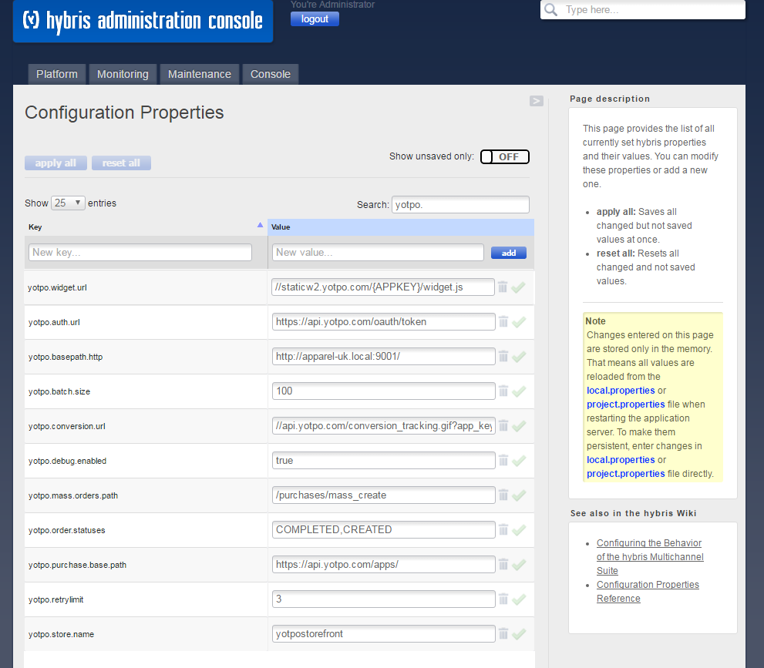

|  |  |
| --- | --- |
| Custom Attribute Name | Function |
| yotpo.auth.url | This attribute used to contain the Yotpoauthentication URL |
| yotpo.widget.url | This is the URL to load widget content from Yotpo |
| yotpo.mass.orders.path | The attribute contains the Yotpomass order path. |
| yotpo.purchase.base.path | This attribute containYotpobase path for any purchase. |
| yotpo.batch.size | The attribute contains batch size for number of products that need to be processed at once, while loading reviews and bottom line. |
| yotpo.basepath.http | The base path of current storefront. |
| yotpo.retrylimit | The attribute is to configure retry limit if yotpo authentication fail. |
| yotpo.debug.enabled | The flag controls the debug log level in whole Yotpo cartridge. By default the debug log will be disabled, therefore to enable the checkbox should be checked. |
| yotpo.conversion.url | This is the URL of the conversion tracking. |
| yotpo.store.name | The attribute contains name of the storefront. |
| yotpo.order.statuses | This attribute is to configure order statuses to export in export purchase feed. |

**Note:**Update the **"**yotpo.store.name" and "yotpo.basepath.http " as per requirements, Other attributes has default values are already set; therefore you don’t need to change anything unless needed. To make permanent change, always edit yotpoproject.properties file. Any changes in admin configuration is temporary

## Storefront Functionality

N/A

# Known Issues

N/A

# Release History

|  |  |  |
| --- | --- | --- |
| **Version** | **Date** | **Changes** |
| 1.0 | 31/03/2017 | Initial Draft. |
| 1.1 | 08/04/17 | Review and Updated |

